ORGANIZING COMMITTEE:

Chairman:
Serhiy Shkarlet, Doctor of Economics, Prof., Honoured Worker of Science and Technology of Ukraine, Rector of Chernihiv National University of Technology (CNUT).

Deputy Chairmen:
Merab Khalvashi, Cand. Sc. (History), As. Prof., Rector of Batumi Shota Rustaveli State University
Ivan Varbanov, Ph.D, Prof., Rector of D.A. Tsenov Academy of Economics
Stanisław Bielecki Ph.D., D.Sc., Rector of the Lodz University of Technology
Viktoriia Marhasova, Doctor of Economics, Prof., Head of the Department of Accounting, Taxation and Audit

Members of the Organizing Committee:
Olena Akymenko, Ph.D. in Economics, As. Prof., As. Prof. of the Department of Accounting, Taxation and Audit;
Valentyna Hlyvenko, Ph.D. in Economics, As. Prof., Prof. of the Department of Accounting, Taxation and Audit;
Kateryna Hnedina, Ph.D. in Economics, As. Prof., As. Prof. of the Department of Accounting, Taxation and Audit;
Tatiana Hohol, Doctor of Economics, As. Prof., Prof. of the Department of Accounting, Taxation and Audit;
Liudmyla Ivanova, Ph.D. in Economics, As. Prof., As. Prof. of the Department of Accounting, Taxation and Audit;
Valentyn Nekhai, Ph.D. in Economics, As. Prof., As. Prof. of the Department of Accounting, Taxation and Audit;
Yaroslav Petrakov, Ph.D. in Economics, As. Prof., As. Prof. of the Department of Accounting, Taxation and Audit;
Oleksandr Sydorenko, Ph.D. in Economics, As. Prof., As. Prof. of the Department of Accounting, Taxation and Audit;
Yurii Skosyr, Ph.D. in Economics, As. Prof., As. Prof. of the Department of Accounting, Taxation and Audit;
Nadiia Yushchenko, Ph.D. in Economics, As. Prof., As. Prof. of the Department of Accounting, Taxation and Audit;

REGISTRATION CARD
of the ІI international research and practice conference “Accounting, taxation, analysis and audit: current state, issues and prospects of development”
Name, Surname _____________________________
Scientific degree ____________________________
Academic title_______________________________
Position ___________________________________
Institution __________________________________
Contact phone_______ ________________________
E-mail _____________________________________
Address____________________________________
Section______ ______________________________
Number of collections of abstracts_______________
The form of participation – distant



Chernihiv National University of Technology
Batumi Shota Rustaveli State University (Georgia)
D.A. Tsenov Academy of Economics (Bulgaria)
Lodz University of Technology (Poland)
Department of Accounting, Taxation and Audit

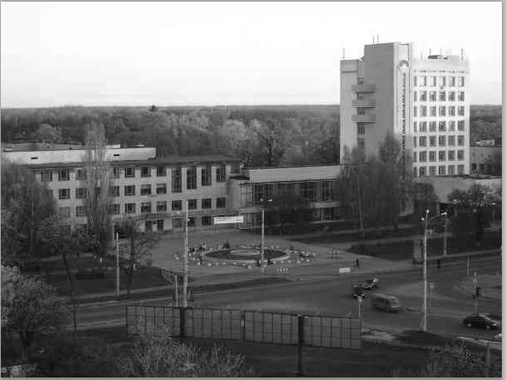

INVITATION

ІII international research and practice conference “Accounting, taxation, analysis and audit: current state, issues and prospects of development”

November 27, 2017

Chernihiv
Dear Colleagues!
On November 27, 2017 at Chernihiv National University of Technology there is the IІI international research and practice conference “Accounting, taxation, analysis and audit: current state, issues and prospects of development” (distant form). Scientists, teachers of higher educational establishments, PhD students, practitioners, entrepreneurs and students are invited to participate in the conference.
Aim of the event is to share experience of scientific research on the issues of accounting, analysis and audit in an enterprise management system.

CONFERENCE SECTIONS:
- National and international experience and directions of accounting development as a science and practical activity;
- Accounting and analytical support of enterprises reporting as a basis for management decisions at the micro and macro levels;
- Economic analysis of enterprises activity: state and development prospects.
- International and national experience of organization, functioning and development of audit.
- Accounting and analytical support of the economic security of an enterprise.
- Taxation of companies activity: issues and development prospects;
- Information systems and technologies in the system of accounting and analytical support for making managerial decisions in accounting, analysis, audit and taxation

CONFERENCE VENUE
Chernihiv National University of Technology. Address: 95 Shevchenka str., 14027 Chernihiv, Ukraine.
Conference language: Ukrainian, Russian, English.

CONFERENCE CALENDAR

Till November 15, 2017 – reception of registration cards and materials for participation in the conference.

November 27, 2017 – conference.

CONFERENCE MATERIALS
Collection of abstracts of the conference will be sent to the address given in the registration card.

Requirements for abstracts
Size: not more than 2 pages of A4 format.
The font: Times New Roman, 12.
The line spacing - 1.0.
Alignment - justified..
Page settings: paragraph – 6.3 mm; margins – 20 mm on all sides.
List of sources is given at the end of an abstract (designed by the requirements of HAC, see Bulletin № 5, 2009) with a compulsory reference to the text in square brackets.
It is obligatory to indicate in abstracts: UDC, Name, Surname, position, place of work (study), abstract title, key words.

Example of abstracts.
UDC 657
Oleksandr Sydorenko, Ph.D. in Economics, Associate Professor, Associate Professor of the Department of Accounting, Chernihiv National University of Technology, Chernihiv, Ukraine

ISSUES OF PROVISIONS ACCOUNTING AND THEIR SOLUTION

Key words: accounting, provision, write-off, reduction, reversal
During the economic activities of economic entities obligations arise. One type of obligations under the P(s)A 11 "Obligation" is a provision.

List of sources: 1. Vasyl Len. Accounting in Ukraine: basics and practice. [study guide] / V. Len, V. Hlyvenko. – Kyiv: Center of educational literature, 2008. – 608 p.

Authors send registration card, abstracts and copy of the payment receipt to the organizing committee e-mail no later than on November 15, 2017 (the letter topic: Conference): kafoa.dtu@gmail.com
Example of filenames: Dubovik_teza; Dubovik_karta; Dubovik_oplata. File format: doc.

PAYMENT FOR PARTICIPATION
Registration fee of a participant, both from Ukraine and abroad: 150 UAH.
Payment details: Chernihiv National University of Technology. Code 05460798 Current Account 31251264206996 in DKSU s. Kyiv MFO 820172. IPN 054607925261. Purpose of payment: For participation in conference Name Surname.
For one report (regardless of the number of authors) one author’s copy of the collection of conference abstracts is sent.

Conference coordinator:
Oleksandr Sydorenko, Ph.D. in Economics, Associate Professor, tel. +38097 440 75 53.
E-mail of the Department: kafoa_dtu@ukr.net

We hope for your interest and cooperation!
Yours faithfully,
Organizing Committee

