JAVAMACH CLUSTER - SYNERGETICS OF INFROMATIC, QUASIMATERIAL AND ENERGY FLOWS IN INDUSTRY 4.0

Dobrotvorskiy S.S, Doctor of Technical Sciences, Professor,
Sokol E.I, Doctor of Technical Sciences, Professor,
Permyakov A.A. Doctor of technical sciences, professor,
Gnuchikh S.S, post-graduate student
The National Technical University "Kharkiv Polytechnic Institute"

The current acceleration of scientific and technological progress is based on the use of the cluster approach. This approach is especially important when solving the problems of "Industry 4.0", which are global in nature and unite all aspects of life and production. A comprehensive approach to the solution of such problems is necessary, taking into account the synergetics of information, quasi-material, energy and other flows. Today there is no single approach to the formation of a cluster model. In general, associations are based on an industrial basis and close geographical position [1,2]. As a rule, …

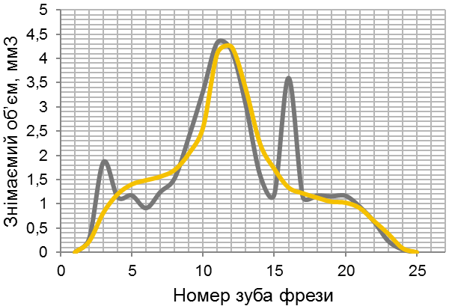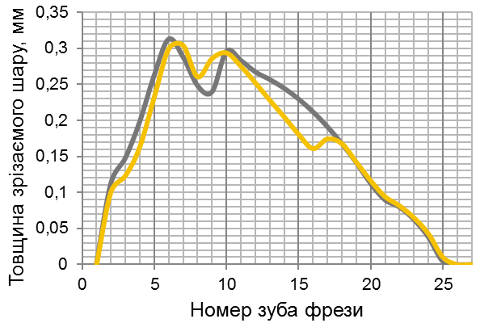
1
2
Центр. зуб
Центр. зуб
2
1
а) б)
Рис.3. Параметри зрізуваного шару матеріалу зубами черв’ячної фрези: а) об’єм матеріалу за цикл, б) максимальна товщина зрізу за цикл. 1- станд. фреза, 2 – фреза [3].

The main goal is the creation in the future of a domestic system such as ERP. taking into account the synergetics of information, quasi-material, energy flows and a high degree of intellectualization.
In conclusion, it is necessary to note the prospects for the dissemination of such a cluster approach within the whole institute with the invitation to interested universities, enterprises, firms in JavaMach Cluster.

References:
1. Porter M. International competition - M .: Intern. relations, 1993. - 896 p.
2. Porter M. Competition - M .: Williams, 2001. - 495 p.3. Herbert Schildt The Complecte Reference. Ninth Edition. Fully updated for Java SE 8 (JDK 8) -Oracle Press, 2014. -1243 p.

